Signals And Transforms

# Overview

[Signals And Transforms](https://github.com/hybridmachine/DSP/releases) is a signal processing platform written in C# for Windows PCs. It is inspired by (but not affiliated with) the book “[The Scientist and Engineer's Guide to Digital Signal Processing](https://www.dspguide.com/) By Steven W. Smith, Ph.D.”. This application is being created primarily as a learning exercise in signal processing but with the hopes that others may find it useful in both their learning and in practical application. Source and binary are freely available on GitHub at <https://github.com/hybridmachine/DSP> and the code is licensed under an [MIT license](https://github.com/hybridmachine/DSP/blob/master/License.txt).

# Signals

# Filters

## Windowed Sync Filters

Windowed Sync Filters are implemented in the SignalProcessor.dll and the implementation is based on the algorithm from [P 290](https://www.dspguide.com/CH16.PDF#page=5&zoom=auto,-310,23) Equation 16-4 of ISBN 0-9660176-3-3 "The Scientist and Engineer's Guide to Digital Signal Processing”

## Custom Filters

Users can specify custom filters in a CSV with a single header row followed by rows specifying the magnitude and phase of each value in a filters frequency response.

**Figure 1. Example CSV file contents**

**Magnitude,Phase (rad)**  
0.999999999999997,0  
0.999891186269006,-3.11723922216662  
1.00001879784316,0.0487068628463591  
0.999900529834424,-3.06853235932026  
0.998472962300293,0.0974137256927062  
0.942513911985374,-3.01982549647391  
…

Note that the header is required (the code always skips the first line). The content of the header is not checked but the values above should be used so that users reading the file will know the content of each column. Quoting is allowed, Excel may automatically quote values if you edit/create the file with it.

### Importing a custom filter

1. Navigate to the filters page by clicking the “Filtes” ribbon button highlighted in red in the image below.
2. Select the import button on the bottom right of this page (highlighted in red on the bottom right of the image below).  
   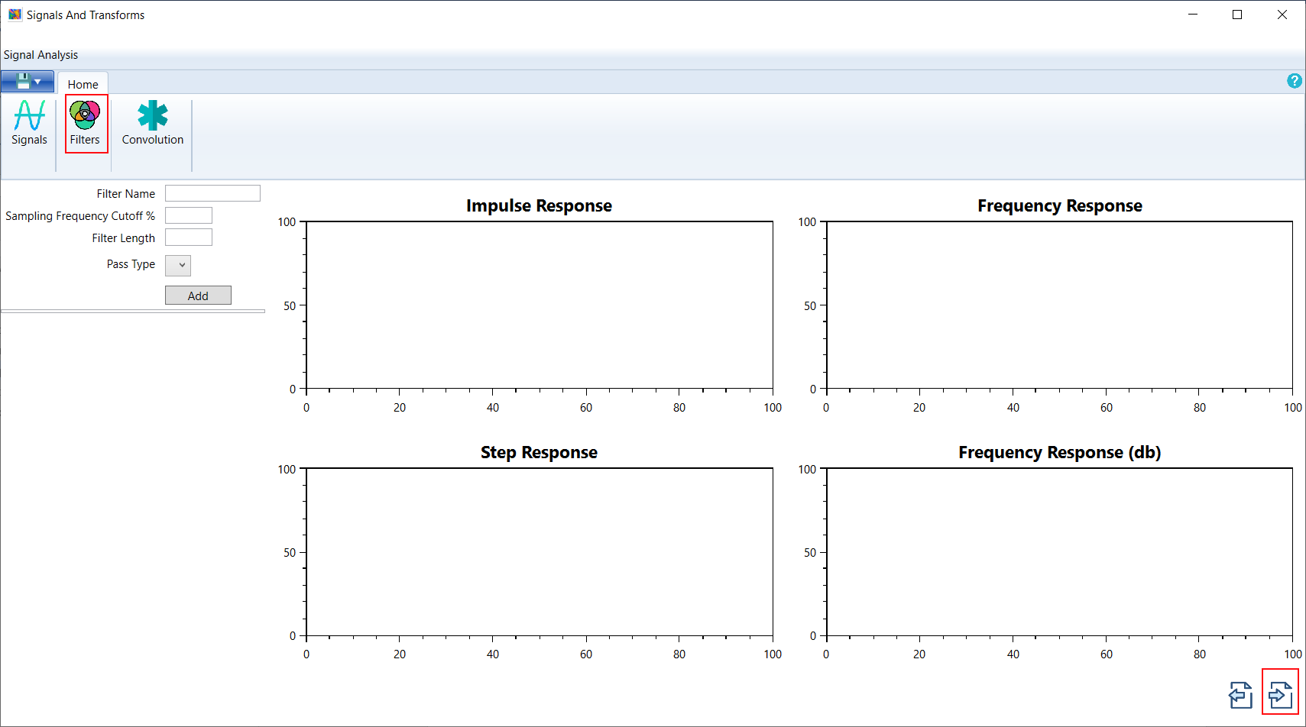
3. Select the CSV file in the file dialog box that displays. On successful import, the filter is added to the list of filters on the left and it is summed with any already active filters in the workbook. In this example it is the only filter in the workbook so its properties are displayed.  
   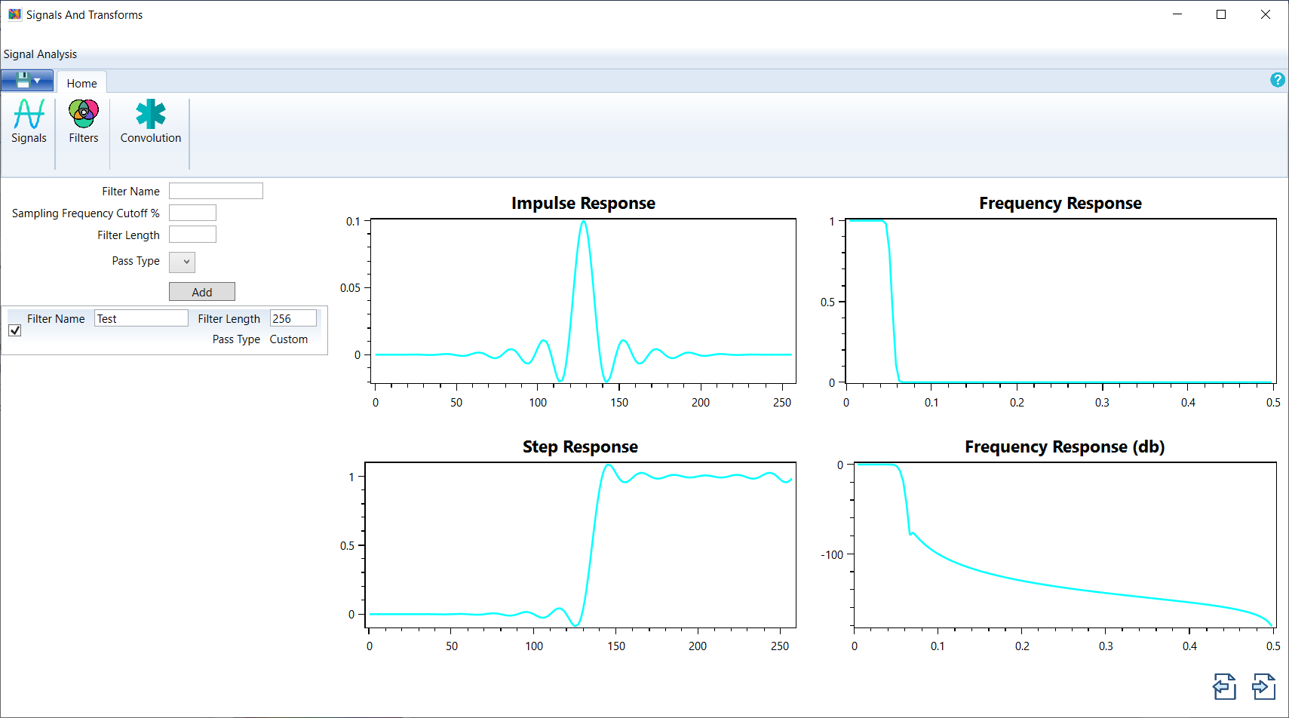

## Filter Details

The panel, on the right of the filter view, displays the details of the resultant combination of all active source filters, listed on the left. Source filter active state is controlled by the checkbox on the far left of the filter in the source filter list.

## Filter Combination

The source filter combination mode is controlled by choosing the mode at the bottom left of the filter summary. Filters combine either in a simple sum or via convolution. A simple sum is typically used to form a band reject filter, convolution will convert this into a band pass filter.

# Convolution of Signals with Filters

# Developer Guide

## Workbook File Format

The workbook contains signal, filter definitions, workbook metadata, and settings. This allows users to save their work, share it, and load it later for editing and use. The file format is a sqlite3 database file with the file extension changed to ‘.stw’ (standing for Signals and Transforms Workbook). Users can inspect the inner structure of the file using any freely available sqlite database inspection tool such as “[DB Browser for SQLite](https://sqlitebrowser.org/)”. During early development, the schema is changing often. The latest schema information can be gathered from the data access layer code at <https://github.com/hybridmachine/DSP/tree/master/Signals%20And%20Transforms/DAL>